**Bollo Kamara Website Redesign**

**Quick Points**

Outdated site

Header

Navigation Bar

Font

Slide animations

JPG Quality

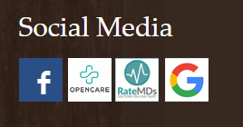Logo Quality redesign

Carousel is slow

Color Palette

Social Media Links

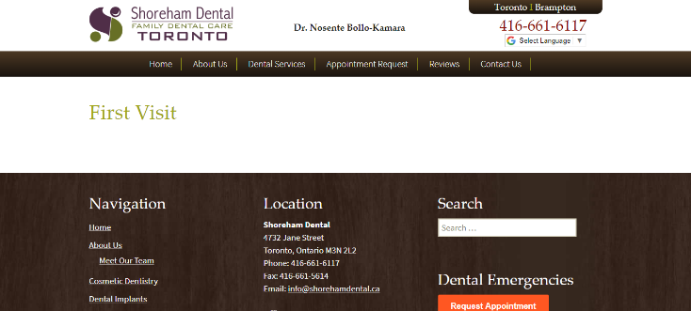**Information Architecture**

First visit link is drabby. Poor quality jpg and there’s no information there

Dental Emergency should be at the top of the page for call to action

Footer is packed with unnecessary information. Could use an arrow that goes back up to page

About Section – Clutter

**Search Engine Optimization**

**Security**

Website is not secure

I am passionate about using a high level of research to execute designs that provide customers with an excellent experience. The innovative technology that that Square is creating really excites me. I want to be at for front of design and have the opportunity to execute my knowledge and grow with your company.

I'm impressed by D2L commitment to using user research to create tools and software people love. This position is perfect for me. I am passionate about using a high level of research to execute designs that provide customers with an excellent experience. I want to be at for front of research and design and have the opportunity to execute my knowledge and grow with your company.

UX Designer at Cority

User experience researcher at Quest trade

UX Designer at Vitamin T

UX/UI Designer | Researcher | Digital Marketing Specialist